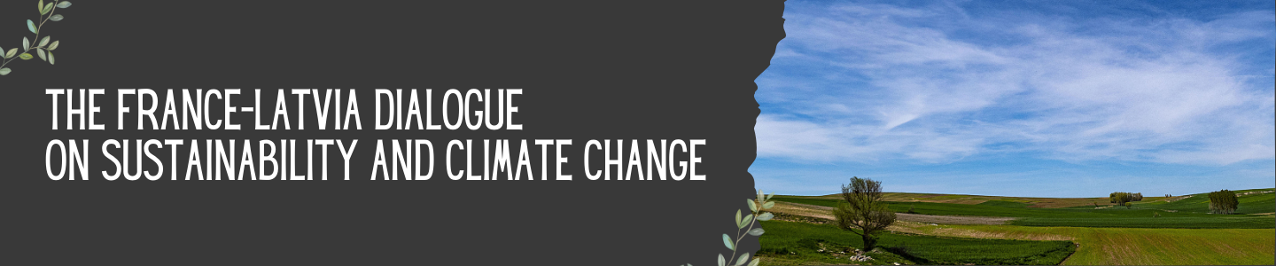
France-Latvia Dialogue on sustainability and climate change
April 15 2024 15h15-17h45
University of Latvia, House of Science, Jelgavas street 3, auditorium Alfa

15.15 Registration
15.30 Official Opening (15 min)
- Rector Prof. Gundars Bērziņš (tbc)
- H.E. Ms. Aurélie Royet-Gounin, Ambassador of France to Latvia
- H.E. Mr. Kaspars Melnis, Minister for Climate and Energy of Latvia (tbc)
- Mr. Renārs Kairis, Chairman of the Eco Council of University of Latvia
15.45 Keynote speech by Sophie Szopa, IPCC, Laboratoire des sciences du Climat et de l’Environnement: “Climate Change: science-based state of the art and challenges”
16.15 Panel discussion (75 min): Solutions and best practices for climate change mitigation and adaptation – Moderator: Xavier Landes (SSE Riga)
- Sophie Szopa, Laboratoire des sciences du Climat et de l’Environnement, France
- Yann Françoise, Deputy head of Climate and Ecological Transition Directorate, Head of the climate department at City of Paris, France
- Jānis Brizga, Researcher at the University of Latvia, department of geography and earth sciences, Latvia
- Vineta Kleinberga, Researcher at the Rīga Stradiņš University, Faculty of Social Science, Latvia
- Laura Treimane, Sustainability Project Manager at the Bank of Latvia

17.30 Closing remarks by Robert Vautard IPCC and senior climate scientist at the National Centre for Scientific Research at Institut Pierre-Simon Laplace in Paris: “IPCC role and ongoing activities”
17.45 Networking session

